Export SunDose compatible Dose-Profiles from TPS
Date of Release: 04/06/2024
Script Name: SunDoseProfileExport2 (launched using: ‘ProfileExportLauncher2.cs’)
Release Version: 1.02
Script Written by: Joshua Hiatt
Checked by: Scott Piggott
TPS Version: Eclipse 16.1

Intended use:
This script will prompt the user to select a reference point in the plan. From which the user can choose to export either PDD or profiles of arbitrary length, arbitrary step-size and with user specified normalisation applied. The exported values are contained in SunDose formatted text files that can be imported into SunDose, to facilitate comparison between measured and TPS values using the tools within SunDose. The script also allows the user to easily export orthogonal dose-profiles for all reference points contained within the plan as a time-saving measure.
Instructions:
- Open the Aria T-Box External Beam Planning, and navigate to the desired plan.
- Open Tools -> Scripts
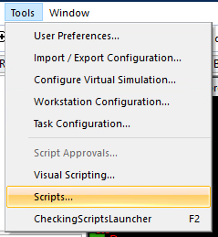
- (FIRST TIME USE ONLY): Select ‘Change Folder’
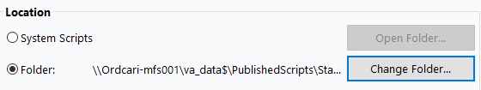
and select: ‘\\Ordcari-mfs901\va_data$\PublishedScripts\StandAlone\BeamProfiles’, now select the ‘SunDoseProfileExport2’ from the scripts list and click ‘Add to Favourites’. It will now subsequently be accessible directly from the scripts menu.
- Run the script, follow the prompts to choose desired reference point(s). The output is exported to ‘N:\Team\Orange\Radonc\RT - Physics\TPS_Scans_ForSunDoseImport’
- Open a project in SunDose and select import, change the file type to the 2nd or the 3rd option (‘.snctxt’) and click import. Manually edit any required parameters (e.g. field-size).

Limitations:
- Requires dose calculated, as well as a reference point(s) within the phantom body.
- Profile/PDD values outside of the calculated dose will return a ‘NaN’ value, and cannot be imported.
- Profile/PDD step-sizes must be whole number integers.
- Profile Depth, field-size and other parameters in SunDose may be incorrect because many of these are hard-coded within the script. If accurate data descriptions are important, the user is advised to manually edit these in the SunDose software. For profiles the depth will need to be manually edited in SunDose.
- Because a certain level of trickery is required to create a file that can be imported into SunDose, the text files will contain raw-values from a “measurement” (these raw values are not used in the SunDose profiles/PDDs). The corrected values will be accurately sent from the TPS into the text file.
- The script assumes the phantom is in Head-First Supine setup. The script converts from DICOM co-ordinates to those used in the water tank via the following conversion:
//Water tank co-ords are x = crossline, y = inline, z = depth, units are 'cm' so must also convert from mm.

//whereas DICOM co-ordinates (in HFS) are x = crossline, y = depth, z = inline.
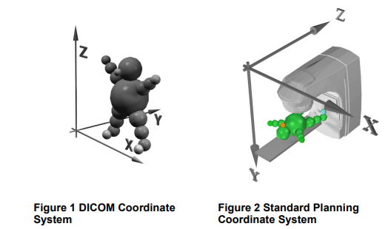
Figure 1: DICOM (scripting co-ordinates) and Eclipse TPS standard co-ordinates. From Eclipse Scripting API Reference Guide [1].
- If an alternative setup is used in the TPS or measurement geometry, the user is encouraged take care that correct co-ordinate transforms have been applied.
- The depth value for PDDs is with respect to the reference point. E.g. the reference point is at a ‘depth’ of 0 cm, even if the selected reference point is not located at the surface.
- Beam and energy parameters are grabbed from the Last beam within the plan. The script may label energies and modalities incorrectly (or not work at all) if this is a setup field.
- Script will grab the plan dose, separate plans should be used for different energies and field-sizes.
- Only orthogonal dose-profiles can be exported.
- Users must check the exported profiles/PDDs are correct, this script is not a substitute for a physicist. At a minimum conduct spot-checks.
References
[1] Eclipse Scripting API Reference Guide, Aria Eclipse V16.1, March 2020, Publication ID: P1044617-001-A, Varian Medical Systems.
Appendix I
Process Replaced:
The manual method to create a dose-profile that can be imported into SunDose is summarised briefly below. The manual method is prone to errors, is very tedious and is now completely replaced by a simple script.
- Manually align Dose Profile tool to give desired length and centring.
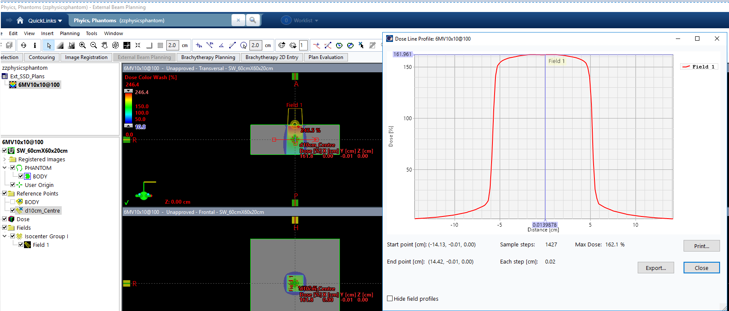
- Make a note of the desired normalisation value to apply, then click ‘export’ as a .txt.
- Open the text file, and copy the position and dose values into excel
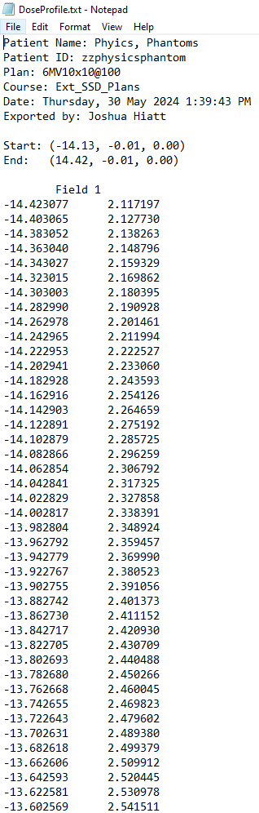
- Apply the normalisation required to the dose value, and convert to percentage in excel.
- Create a .snctxt file, by exporting a similar type of measured scan from SunDose.
- Rename this file (as well as the file-name within the .snctxt header). Modify the position and Dose values by pasting in the values from the excel document. Be mindful to use the correct co-ordinate system. You will likely need to also manually the correct (X,Y,Z) values for the TPS scan. The formatting must be preserved EXACTLY, otherwise you will be unable to import the scans into SunDose.
- Repeat for all other profiles/points.
Open a project in SunDose and select import, change the import file type selection to the 2nd or the 3rd option (‘.snctxt’) and click import. For profiles, after import click on edit and manually change the depth to the correct value (the default depth is given for the reference point in DICOM co-ordinates). No changes to the depth should be required for PDDs, provided the reference point is placed at the surface.
Appendix II – Source code and protections
The source solution code is currently stored in: N:\Team\Orange\Radonc\RT\Temp\AutoPlanProstate, but will eventually be moved to the generic scripting folder once the scripting committee creates it. To modify the script in T-box, the solution will need to be rebuilt into the script folder. The script will then need to be registered and approved (and the old one retired) within the password protected T-box script management tools. Please do not attempt unauthorised modifications – contact Joshua Hiatt or Scott Piggott to make bug reports or feature suggestions.

